# **UNDERGRADUATE THESIS PROPOSAL**



By:

I Wayan Fajar Surya Negara

13616040

Advisor:

1. Dr. Eng. Ridanto Eko Poetro, S.T, M.Sc.
2. Luqman Fathurrohim ST., M.T.
3. Ir. Toto Indriyanto, M.Sc., Ph.D

**AEROSPACE ENGINEERING**

**FACULTY OF MECHANICAL AND AEROSPACE ENGINEERING**

**INSTITUT TEKNOLOGI BANDUNG**

**2021**

# **ABSTRACTS**

This proposal summary will describe a star tracker algorithms problem based on convolution neural network (CNN) algorithms. For the past 40 years, there has been much research about star identification problems. One of the biggest challenges in star identification is when there is a false star, because it can change the distance vectors or the angular separation with the reference stars. CNN on the other hand is a candidate solution for these problems, by treating the star identification problem as a machine vision problem. This study will compare and make an algorithm based on 3 well established CNN architectures which are GoogLeNet, Vgg16, and AlexNet.

Approving,

Advisor 1

Dr. Eng. Ridanto Eko Poetro, S.T, M.Sc.  
NIP: 19700420 199903 1002

Advisor 2 Advisor 3

Luqman Fathurrohim, S.T., M.T. Ir. Toto Indriyanto, M.Sc., Ph.D.  
NIP: 19700420 199903 1002 NIP: 19681028 200604 1016

# **CHAPTER I BACKGROUND**

In order to complete its mission, a satellite requires a system to determine and control the satellite orientation called ADCS (Attitude Determination and Control System). ADCS is a very important part of the satellite and consists of several parts namely sensors, actuators, and OBE (on board electronics) [1]. Sensors on satellites work by observing and sending information in the form of position, direction of motion, and direction of satellite barriers to be converted into satellite attitude data. This data is then controlled and processed by actuators according to the mission needs of the satellite. OBE is the main part of ADCS, in which this system executes attitude determination and control algorithms. There are so many types of sensors in satellites such as star tracker, sun sensor, earth horizon sensor, magnetometer, etc.

Star tracker is one of the most precision attitude determination instruments and not susceptible to environmental disturbances without relying on other navigation systems [2]. Star trackers work by capturing the stars in the field of view (FOV) and comparing that with the stars catalog. Stars catalog data generally uses the Smithsonian Astrophysical Observatory catalog consisting of 258,997 stars with magnitudes below 10 Mv and each has its own right ascension and declination [3].

There are so many star identification algorithms that developed over the past 40 years to solve the full sky star identification problem, and it's divided by 2 categories [4]. The first one is an algorithm to approach star identifications as an instance of subgraph isomorphism, this algorithm works by calculating the angular separations of the stars, for example triangle algorithms [5] and pyramid algorithms [6]. And the second one tends to treat star tracking as a pattern identification problem, this algorithm treats the stars as a unique pattern based on its nearest stars, example for this algorithm is grid algorithms [4] and singular value decomposition algorithms [7].

In 2000, an autonomous star identification algorithm using fuzzy neural logic networks was proposed [8]. The simulation shows that the proposed algorithm can achieve fast recognition speed and high recognition accuracy. There are so many neural networks algorithms that have developed since that time, such as a method based on the counter propagation of neural networks [9]. In that neural networks algorithm, the star tracking problem is treated as a pattern identification problem. Then if there are so many patterns, we can achieve much higher on the accuracy, but that also means much computational operation is needed.

Recent studies on neural networks show that convolution neural networks (CNN) perform much better than the other neural approaches [10]. CNN is a computer program inspired by the ability of the human brain where there is a thought process that requires input to produce output in the form of the results of the thought process. One example is the human ability to recognize handwriting. There are several well-known CNNs, such as GoogLeNet [11], Vgg16 [12], and AlexNet [13]. In this study, the author will compare the performance of those 3 CNN methods and make a star identification algorithm based on those 3 CNN algorithms.

# **CHAPTER II LITERATURE STUDY**

## **2.1 Star Trackers**

A star tracker or star sensor is a sensor that determines the attitude of the satellite in 3 axes at once which is quite accurate so that it is widely used in satellite technology as an ADCS system (attitude determination and control system) [14]. It is because the resources that are needed for star sensor is a star, that has the most potential accuracy on determining satellite attitude based on the theoretical accuracies [5].

|  |  |
| --- | --- |
| **References Object** | **Potential Accuracy** |
| Stars | 1 Arcsecond |
| Sun | 1 Arcminute |
| Earth (Horizon) | 6 Arcminute |
| Magnetometer | 30 Arcminute |

**Table 2.1** Potential Accuracy of references object in ADCS Sensor [5]

The accuracy of the star sensor depends on the technology used, both hardware in the form of cameras, microprocessors, and memory, as well as software in the form of catalogs and identification algorithms. There are three considerations in choosing a star sensor, starting from its accuracy, data processing time, to the required cost.

Star tracker identification problems can divide by 2 categories, the first one is an algorithm to approach star identifications as an instance of subgraph isomorphism, this algorithm works by calculating the angular separations of the stars, example for this algorithm is triangle algorithm [5]. And the second one is treated star tracking as a pattern identification problem, this algorithm treats the stars as a unique pattern based on its nearest stars, example for this algorithm is grid algorithm [4].

Star detection consists of two stages, namely: tracking mode and Lost in Space (LIS) mode [15]. When the star tracker is in LIS mode, then there is no information about the attitude of a satellite, so the full sky identification algorithm [16] is needed. After the star tracker collects information about the initial attitude, the star tracker will automatically switch to the tracking mode. The process in the tracking mode is faster than the LIS mode because the information that is collected in the LIS mode will be used to predict the future attitude of the satellite.

A collection of starlight captured by the camera is then translated into pixels at cartesian coordinates according to the Field of View (FOV). The position of one star is then selected as the reference and five closest star from the reference star then considered as adjacent stars thus that pattern compared with an inertial reference, so that the orientation of the satellite's attitude can be known. Inertial reference data is data from the star catalog stored in the memory of the star sensor electronic unit. This study uses SAO (Smithsonian Astrophysical Observatory) star catalog data which contains data on stars with magnitudes below 10 Mv and their positions in celestial coordinates (Right Ascension and declination). The data in the star catalog is then sorted from the lowest magnitude to make it easier to read the data.

Star trackers is made by using some disciplines major such as optics, mechanics, image processing, electronics, embedded computing, and many more. A star tracker normally consists of a baffle, a lens, an image sensor and its circuit board, a signal processing circuit, a housing structure, an optical cube, and other components. The basic structure of a star sensor is shown in this figure:

**Figure 2.1** Star tracker components [17]

The most important component of a star tracker is the image sensor. The image sensor transforms the optical signals that received from the light rays into electrical ones. Usually, image sensors can be grouped into two categories which are CCD and CMOS. The signal processing circuit that is located at the back of the image sensor oversees the storing the image data from the image sensor, timing control, star positioning and star identification process until finally outputting the three-axis attitude.

The star tracker operating principle is shown in this flow chart figure

**Figure 2.2** Star tracker operating system [17]

From that figure we can see that the step of star tracker is

1. The image sensor (CCD or CMOS) captures an image of the boresight pointing in the night sky
2. The image is processed by the signal processing circuit, and information on the position and brightness of the stars is extracted.
3. The image is passed through the star pattern identification algorithm.
4. Corresponding match of the stars is searched through the guide star catalog.
5. From the matched pair, the three-axis attitude of the star sensor is calculated, obtaining the spatial attitude of the aircraft.

## **2.2 Convolution Neural Networks**

Convolutional neural networks are basically a type of neural network that uses convolutional layers (ConvLayers). CNN is a type of neural network dedicated for computer vision tasks such as classifying images. This method is developed by an idea on the mathematical operation of convolution. ConvLayers consist of a set of filters, which we can assume as a 2d matrices of numbers. An example for a filter is an 3x3 filter which consist

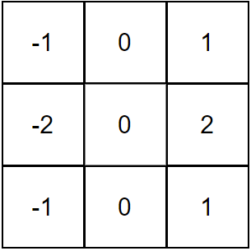

**Figure 2.1** The vertical sober filter

The input image will be convolving with the filters to produce an output image, the step for this process is consist

1. Overlaying the filter on top of the image at some location.
2. Performing **element-wise multiplication** between the values in the filter and their corresponding values in the image.
3. Summing up all the element-wise products. This sum is the output value for the **destination pixel** in the output image.
4. Repeating for all locations.

For example, there is a 4x4 grayscale image

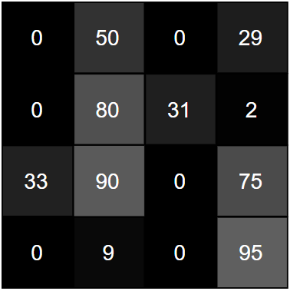

**Figure 2.2** 4x4 grayscale image input

By convolving the input with the filters start from the top left, then the top right, going to the left bottom and finishing in the right bottom, we will get a 2x2 output image as shown.

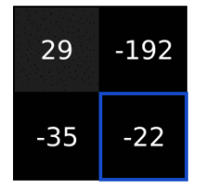

**Figure 2.3** 2x2 output image

After zooming out for a bigger problem, then we will see what this method actually does, by using the 3x3 filter, we can get an example of what vertical sobel filter does



**Figure 2.3** An image convolved with vertical sober filters

We can see that the sober filters are actually doing an edge detector for an image, the output images indicate there is a strong edge around the original image.

Convolutional neural networks can be applied to star identification systems by training star images of the same attitude. The training set of the star images need to be varied so that the neural network will learn from the different variations within the same class. Markers on the star positions can also be placed so that it can ease the neural network training.

# **CHAPTER III RESEARCH METHODOLOGY**

The methodology that is used in this study is based on literature study and simulation using a digital software python. The literature studies are conducted by reading textbooks and scientific journals that are related to existing star sensors, machine learning especially convolution neural networks. After literature study is done on the mechanisms of modern star trackers and the exploration of the GoogLeNet, Vgg16, and AlexNet. Those three algorithms are then evaluated by simulating it to find the advantages and disadvantages. After that, the author will develop algorithms based on CNN. The newly developed algorithms are then tested using digital simulation. The digital simulation’s purpose is to retrieve the methods’ performance metrics. After obtaining its performance metrics, it is evaluated, and the writer can come up with solutions and modifications to the system to further increase the performance. If the performance cannot be further increased, the thesis is finished. The flowchart of this research methodology can be shown below:

**

**Figure 3.1.** Methodology flow chart

The research project timeline is targeted to be done in July 2022, with the timeline as follows this table timeline.

|  |  |  |
| --- | --- | --- |
| Month | Main Step | Detailed Steps |
| January | ***Literature Study*** | Study About Star Sensor Operating Principle |
| Deep Learning with 3 CNN that mentioned |
| Make the **Chapter 2** of the undergraduate thesis |
| February | ***Chapter 1***  ***Introduction*** | Abstract |
| Research Background, objective, scope, Assumptions and Methodology |
| Undergraduate Thesis Outline |
| March | ***Chapter 3***  ***Star Identification Algorithm Based on CNN*** | Make algorithm based on 3 CNN |
| Simulation on Phyton |
| Simulation result and analysis |
| April | ***Chapter 4***  ***Algorithm Modification*** | Current Design Analysis and Flaw Identification |
| Coding Development and Modification |
| Phyton Simulation Testing |
| May | ***Chapter 5***  ***Conclusions and Recommendations*** | Results Comparison and Analysis |
| Make all the research report structure. |
| June | Revision and the thesis defence |

**Table 3.1** Research timeline

# **CHAPTER IV INITIAL RESULTS**

Based on the study literature about the CNN on the three algorithms, GoogLeNet, Vgg16, and AlexNet there is the difference between the algorithms

| Based on the CNN Architecture | | |
| --- | --- | --- |
| GoogLeNet | Vgg16 | AlexNet |
| The size of the receptive field in GoogLeNet is 224×224 in the RGB color space with zero mean. “#3×3 reduce” and “#5×5 reduce” stands for the number of 1×1 filters in the reduction layer used before the 3×3 and 5×5 convolutions. One can see the number of 1×1 filters in the projection layer after the built-in max-pooling in the pool proj column. All these reduction/projection layers use rectified linear activation  as well. | Vgg16 contains A stack of convolutional layers (which has a different depth in different architectures) is followed by three Fully Connected (FC) layers: the first two have 4096 channels each, the third performs 1000- way ILSVRC classification and thus contains 1000 channels (one for each class). The final layer is the soft-max layer. The configuration of the fully connected layers is the same in all networks. | AlexNet contains 5 convolutional layers as well as 3 fully connected layers for learning features, it has max-pooling after the first, second and fifth convolutional layers. In total it has 650K neurons, 60M parameters, and 630M connections. |

**Table 4.1** Architecture difference of GoogLeNet, VGG16, and AlexNet

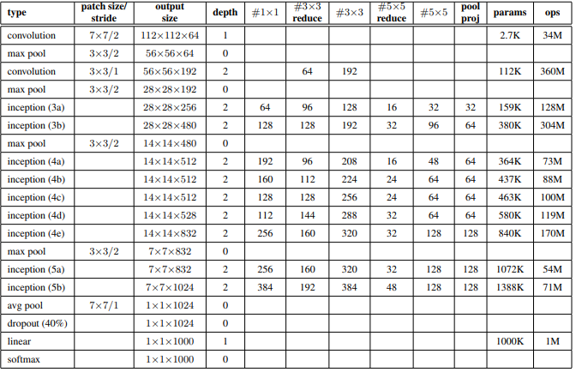

**Figure 4.1** GoogLeNet architecture

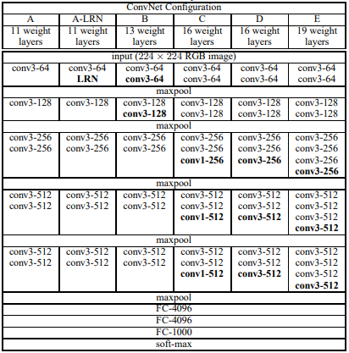

**Figure 4.2** Vgg16 architecture

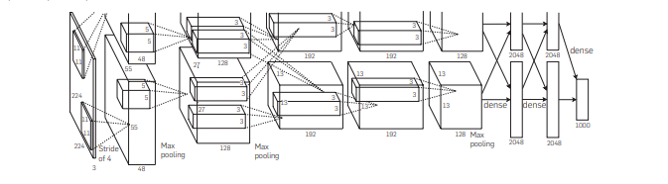

**Figure 4.3** AlexNet architecture

# **REFERENCES**

1. Bolandi H, Haghparast M, Saberi FF, Vaghei BG, Smailzadeh SM. *Satellite Attitude Determination and Control. Measurement and Control. 2012;45(5):151-157*. doi:10.1177/002029401204500505
2. P. Wang, L. Lan, Y. Han, G. Wang and H. Quan, *Design of a Miniature CMOS APS Star Tracker,* International Journal of Electronics and Electrical Engineering, Vols. 4, No. 1, 2016.
3. Smithsonian Astrophysical Observatory, *Star Catalog: Positions and Proper Motions of 258,997 Stars for the Epoch and Equinox of 1950.0,* Washington, D.C.: Publications of the Smithsonian Institution, 1966.
4. Padgett, C., & Kreutz-Delgado, K. (1997). *A grid algorithm for autonomous star identification. IEEE Transactions on Aerospace and Electronic Systems, 33(1), 202–213.* doi:10.1109/7.570743
5. Liebe, C. C. (1992). *Pattern recognition of star constellations for spacecraft applications. IEEE Aerospace and Electronic Systems Magazine, 7(6), 34–41.* doi:10.1109/62.145117
6. MORTARI, D., SAMAAN, M. A., BRUCCOLERI, C., & JUNKINS, J. L. (2004). *The Pyramid Star Identification Technique. Navigation, 51(3), 171–183.* doi:10.1002/j.2161-4296.2004.tb00349.x
7. J. Juang, H. Kim and J. Junkins, *An Efficient and Robust Singular Value Method for Star Pattern Recognition and Attitude Determination*, J. Astronaut. Sci., vol. 52, pp. 211-220, 2004.
8. Hong, J., & Dickerson, J. A. (2000). *Neural-Network-Based Autonomous Star Identification Algorithm*. Journal of Guidance, Control, and Dynamics, 23(4), 728–735. doi:10.2514/2.4589
9. Jing, Y., & Liang, W. (2012). *An improved star identification method based on neural network. IEEE 10th International Conference on Industrial Informatics.* doi:10.1109/indin.2012.6301126
10. Cheng, J., Wang, P., Li, G., Hu, Q., & Lu, H. (2018). *Recent advances in efficient computation of deep convolutional neural networks. Frontiers of Information Technology & Electronic Engineering, 19(1), 64–77.* doi:10.1631/fitee.1700789
11. Szegedy, C., Wei Liu, Yangqing Jia, Sermanet, P., Reed, S., Anguelov, D., … Rabinovich, A. (2015). *Going deeper with convolutions. 2015 IEEE Conference on Computer Vision and Pattern Recognition (CVPR).* doi:10.1109/cvpr.2015.7298594
12. Simonyan K, Zisserman A, 2015. *Very deep convolutional networks for large-scale image recognition*. https://arxiv.org/abs/1409.1556
13. Krizhevsky, A., Sutskever, I., & Hinton, G. E. (2017). *ImageNet classification with deep convolutional neural networks. Communications of the ACM, 60(6), 84–90.* doi:10.1145/3065386
14. M. A. Saifudin and R. H. Triharjanto, "Algoritma Pengenalan Pola Bintang untuk Deteksi Posisi Bintang pada Star Sensor Satelit LAPAN," Jurnal Teknologi Dirgantara, vol. 8, no. 1, pp. 36-42, 2010.
15. F. L. Markley and J. L. Crassidis, Fundamentals of Spacecraft Attitude Determination and Control, New York: Microcosm Press and Springer, 2014.
16. Spratling, B., & Mortari, D. (2009). *A Survey on Star Identification Algorithms. Algorithms, 2(1), 93–107.* doi:10.3390/a2010093
17. G. Zhang, Star Identification Methods, Techniques and Algorithms, Beijing: National Defense Industry Press, 2017.